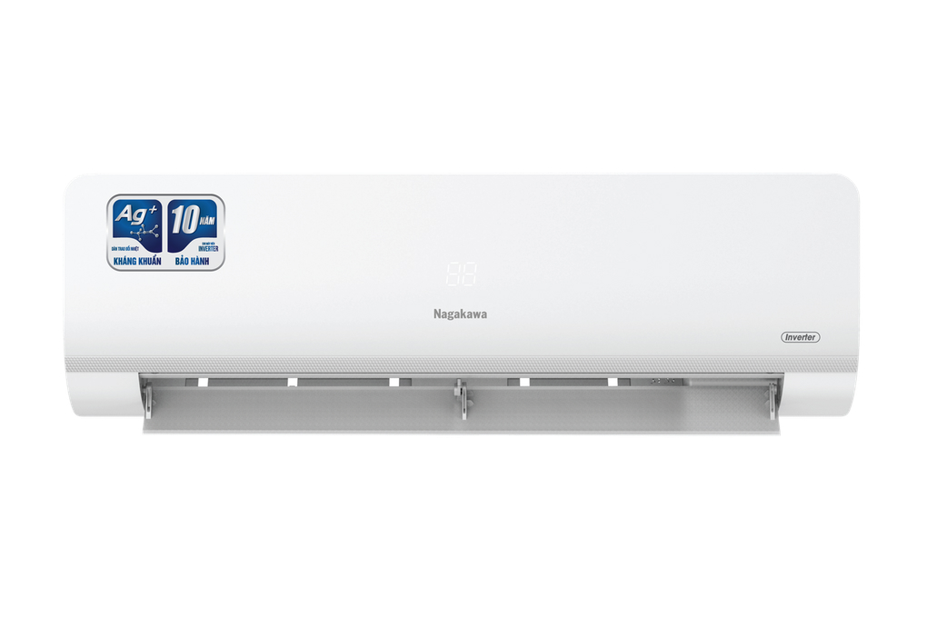

**18,990,000 VND**

 0% installment payment

**Technical specifications of Nagakawa Inverter 2.5 HP NIS-C24R2H10 air conditioner**

* Machine Type:

1 way (cooling only) With Inverter

* Cooling capacity:

2.5 HP - 22,500 BTU

* Effective cooling range:

From 30 - 40m² (from 80 to 120m³)

* Dust filter, antibacterial, deodorant:

5-layer integrated air cleaning system

* Power saving technology:

EconomyInverter

* Rapid cooling:

Super

* Utilities:

Smart operating mode Smart Sleep operating mode Self-cleaning function I Feel temperature sensor Super quiet operation Quiet Turn on and off timer Automatically restarts when power is restored

* Power consumption:

2.15 kW/h 5 stars (Energy efficiency 4.57)

* Cooler:

Length 103.2 cm - Height 32.7 cm - Thickness 22.7 cm - Weight 12.5 kg

* Outdoor:

Length 81 cm - Height 58.5 cm - Thickness 28 cm - Weight 33 kg

Introducing the company 

- Vietnamese brand.  
- Established in 2002.  
- Diverse business products: air conditioners, dishwashers, induction cookers,.... with product prices easily accessible to consumers.  
- Achieved many outstanding achievements: Top 100 best products for families and children (2023), golden brand for Vietnamese health (2019),...

[**Nagakawa Inverter 2.5 HP NIS-C24R2H10 air conditioner**](https://www.dienmayxanh.com/may-lanh/nagakawa-inverter-25-hp-nis-c24r2h10)**is an air conditioner line that possesses electricity-saving Inverter technology, the condenser and condenser operate stably for optimal capacity, and the self-cleaning mechanism increases cleaning efficiency as well as improving Long life for the machine.**

**Design overview**

**Cooler**

- Delicate rounded rectangular design, luxurious white color suitable for almost any interior space. Equipped with an LED screen displaying the temperature to help observe and monitor easily, especially at night you no longer need to use a flashlight to check the temperature on the remote.

- [**R32 gas**](https://www.dienmayxanh.com/kinh-nghiem-hay/cac-loai-gas-tren-may-lanh-588213#r32) is environmentally friendly, has the ability to save electricity, cool quickly and deeply with great cooling efficiency.

**Outdoor**

- Square design, shell is made from sturdy material, good corrosion resistance.

- **The Ag+ ion antibacterial Blue Fin plated heat exchanger**  has the effect of preventing corrosion from many external agents, increasing the ability to operate durably during operation.

[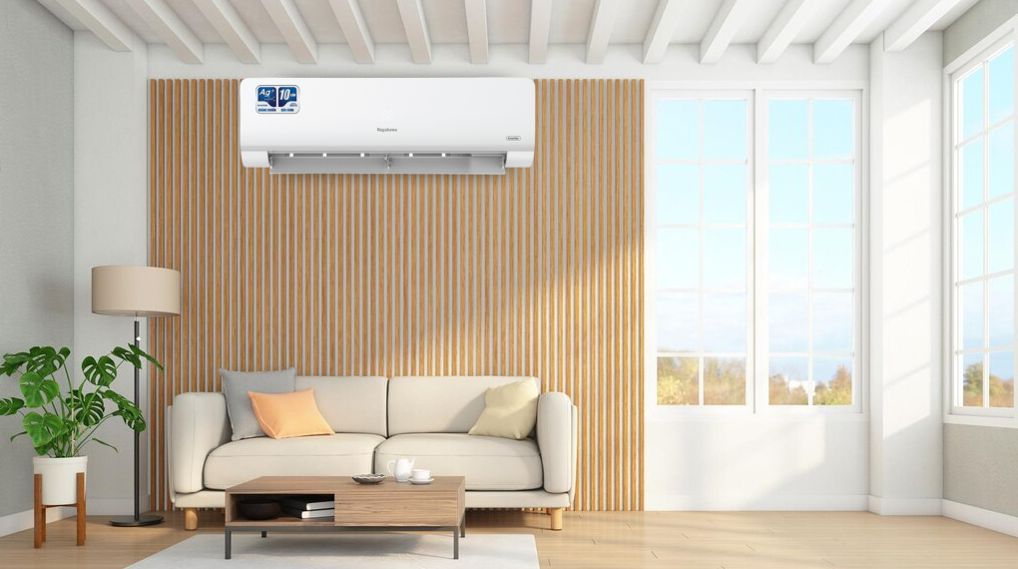](https://cdn.tgdd.vn/Products/Images/2002/299827/may-lanh-nagakawa-inverter-25-hp-nis-c24r2h10-030123-100541.png)

*\* Images are for illustration purposes only*

**Refrigeration technology**

- Cooling capacity of **2.5 HP - 22,500 BTU** , optimal cooling for spaces with an area of  **​​30 - 40m² (from 80 to 120m³)** .

- **Super fast cooling mode** helps increase operating performance, fast cooling helps cool the space instantly, bringing a comfortable feeling, you don't have to spend too much time waiting.

**Air blowing mechanism**

- The 4-way automatic **wind control mode on**[the Nagakawa air conditioner](https://www.dienmayxanh.com/may-lanh-nagakawa) allows the air flaps to swing vertically (up/down) and horizontally (left/right) with the press of a button on the remote, so the cold air is spread evenly throughout. place in the room.

**Power saving technology**

**- Inverter** technology operates smoothly and durably, room temperature is always maintained at a stable level, contributing to saving energy consumption. Besides, **Economy** technology also contributes to optimal energy savings when activated.

**- 5 star** energy label , energy efficiency **4.57** .

**Air filtering ability**

- This [air conditioner](https://www.dienmayxanh.com/may-lanh) is equipped with [a 5-layer integrated air cleaning system](https://www.dienmayxanh.com/kinh-nghiem-hay/nhung-cong-nghe-va-tien-ich-noi-bat-tren-may-lanh-1333427#hmenuid2) , including: HD filter, Hepa filter, Nano Ag filter, green tea filter, vitamin C filter layer. This filter system Not only does it filter dust and dirt, but it also ensures that the air flow is always fresh and clean, protecting the health of the whole family.

**Utilities**

- **Self-cleaning function** : helps effectively remove bacteria and mold, dries water remaining on the radiator, thereby eliminating the growth environment for pathogens. Besides, this mode also helps the machine operate at optimal capacity, increase service life and save cleaning costs for the whole family.

-  **Automatically restarts when power is** restored: when power is restored, the machine will operate according to previously memorized parameters, you do not need to waste time setting parameters from the beginning.

-  **Timer to turn the machine on and off** : users can set the time the machine operates, avoiding having to wake up to turn it off when the temperature drops low.

-  [Super quiet operation](https://www.dienmayxanh.com/may-lanh-hoat-dong-sieu-em-quiet) : capable of adjusting the engine speed to the lowest level to minimize noise when the air conditioner operates, providing a quiet resting space for the whole family.

*In general, the Nagakawa Inverter 2.5 HP NIS-C24R2H10 air conditioner operates with a capacity of 2.5 HP, suitable for spaces with an area of ​​30 - 40m² (from 80 to 120m³), equipped with energy saving features with technology  . Inverter, 4-way swing mode spreads cold air throughout the space, automatic cleaning, Super fast cooling mode,... bring the whole family a comfortable, pleasant space.*